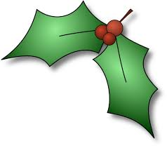
Inn on Loch Lomond Hogmanay Dinner 2019

Canapes
Chestnut Mushroom & Blue Murder Quiche
Black Pudding & Apple Bon Bons
Smoked Salmon & Prawn Sesame Toast

Starter
Guinea Fowl,
Panchetta & Fig Galantine, Pickled Vegetables, Micro Herb Salad

Soup
Parsnip, Cider & Thyme Soup, (v)
With a Kintyre cheddar crouton

Main Course
Black Treacle & Stout Braised Sirloin of Beef,
Horseradish Dumpling, Root Vegetable Galette, Rosemary Duchesse, Caramelised Onion Gravy

Dessert
Ice Cranachan Parfait,
Drambuie Poached Raspberries, Orange & Lavender Short Bread

